STUDENT PLACEMENT ANALYSIS DASHBOARD REPORT

# Name : Srinidhi R

# Usn : 4GW23CI053

# Email : ramdasnidhi@gmail.com

# INDEX :

1. **Project Tittle** ................................................. 3
2. **Problem Statement** ................................... 3
3. **Project Description** .......................... 3
4. **Data and Output Purpose** ...................... 4

## Input Data (MySQL tables)

## Output & Benefits

1. **Solution Plan** .............................................. 4
2. **Diagram Design**

## Activity Diagram

## Data Flow Diagram

1. **Code and Implementation**
2. **Output Screenshots & Explanation** .... 18
3. **Conclusion** ................................................

10. **Closure**

11. **Bibliography**

# 1.Project Tittle :

Placement Analysis Dashboard

# 2.Problem Statement :

The Placement Cell maintains large volumes of data about students, companies, interviews, offers, and recruitment outcomes. However, this data is often stored in raw form and lacks advanced insights. As a result, it becomes difficult to:

* Identify placement trends across batches, branches, and recruiters.
* Measure recruiter performance and student preparedness.
* Track salary variations and conversion rates.

Without a proper analytical system, placement officers rely on manual reports, which are time-consuming and less effective for decision-making.

There is a strong need for a **data-driven system** that performs efficient preprocessing and analysis, and uses visualization techniques to provide actionable insights. Such a system can improve placement strategies, optimize training programs, and enhance student preparedness.

# 3.Project Description :

* This project develops a **Python-based Placement Analytics Dashboard** that transforms raw placement data into meaningful insights. The system leverages **NumPy and Pandas** for data preprocessing and analysis, while **Matplotlib, Plotly, and Streamlit** are used for interactive dashboards and visualization.
* The system provides:
* **Placement Trends Analysis**: Year-wise, branch-wise, and company-wise statistics, along with salary trends (highest, lowest, average).
* **Performance Indicators**: Interview-to-offer conversion rates, top recruiting companies, high-performing students, and placement outcomes correlated with student academic performance (CGPA).
* **Recruiter Insights**: Identifying top recruiters, conversion efficiency, and salary distribution.
* **Student-Centric Insights**: Highlighting departments and CGPA ranges with strong or weak placement performance.
* By combining data analysis with rich visualization, this system acts as a **decision-support tool** for the Placement Cell, enabling administrators, faculty, and students to make informed, data-driven decisions that improve the overall placement process.

# 4.Data and Output Purpose :

## Input Data (MySQL tables) :

The system uses a **relational database (placement_db)** where multiple tables are linked together to provide a complete view of student placement activity:

1. **student**
   * Attributes: *usn, name, dept, batch, cgpa*
   * Purpose: Stores core student information including academic performance (CGPA).
2. **company**
   * Attributes: *cid, company name*
   * Purpose: Maintains details of recruiters participating in placement drives.
3. **performance**
   * Attributes: *usn, cid, status*
   * Purpose: Tracks recruitment outcomes for each student against each company.
   * Status is stored as numeric codes (10 = Placed, 9 = Shortlisted , 0 = Not Eligible, 1 = Unable to Clear 1st Round, 2 = Unable to Clear GD, 3 = Unable to Clear Technical Round , 4 = Unable to Clear HR ).
4. **hiring**
   * Attributes: *hid, cid, ctc, dept, batch , date.*
   * Purpose: Stores salary package (Cost-to-Company) information offered by companies.

## Output & Benefits :

The system transforms raw data from the above tables into meaningful results:

1. **Placement KPIs (Key Performance Indicators)**
   * Total students appearing for placements.
   * Number of students placed.
   * Number of students shortlisted.
   * Overall placement rate (Placed + Shortlisted ÷ Total Students).
2. **Recruiter Insights**
   * Top recruiting companies by hires.
   * Salary trends: highest, lowest, and average package offered.
   * Interview-to-offer conversion rates for each company.
3. **Comparative Analysis**
   * Batch-wise placement outcomes to identify strong and weak years.
   * Department-wise success rates to compare academic streams.
4. **Decision-Support for Training Programs**
   * Identifies gaps in student performance.
   * Helps placement officers design better pre-placement training.
5. **Downloadable Hiring Records**
   * Hiring reports available in CSV format.
   * Facilitates documentation and sharing across departments.

# 5.Solution Plan :

**1. Data Ingestion**

* Data is fetched directly from the MySQL database using the **dbconfig.py** connector.
* Queries join multiple tables (student, performance, hiring, company) to create a consolidated dataset.
* Pandas DataFrames are used for efficient data handling.

**2. Analysis & Processing**

* Placement status codes are mapped into **human-readable categories** (e.g., 10 → Placed, 9 → Shortlisted).
* Filters are applied based on user input: batch, department, or company.
* KPIs such as placement rate, total hires, and salary averages are computed.

**3. Dashboard Interface (Streamlit)**

* Interactive sidebar allows users to set filters.
* KPIs are displayed in **card format** for clarity.
* Data tables are shown with sorting and searching options.
* A download button generates CSV reports for offline analysis.

**4. Visualization (Plotly)**

* **Overall Placement Distribution**: Pie/Bar charts of placement status.
* **Batch-wise Trends**: Placement statistics across years.
* **Branch-wise Trends**: Department-level comparisons.
* **Recruiter Analysis**: Top companies, salary trends, conversion rates.
* **CGPA Impact**: Placement outcomes grouped by CGPA bins.

# 6.Diagram Design:

## Activity Diagram :

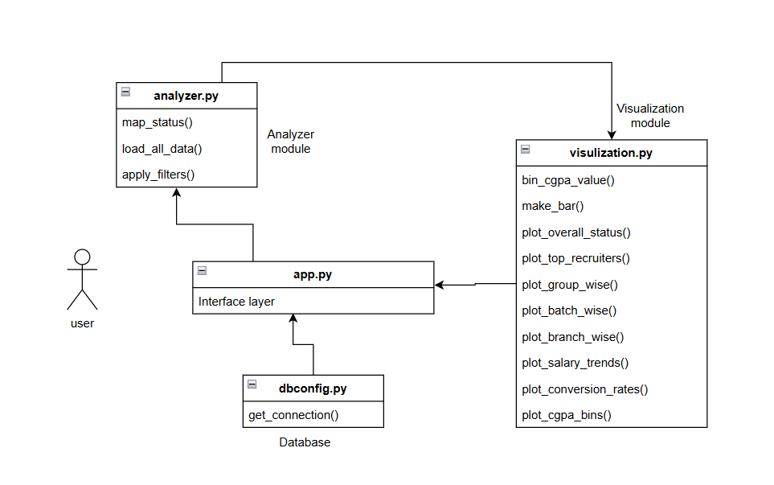

## Data Flow Diagram :

* 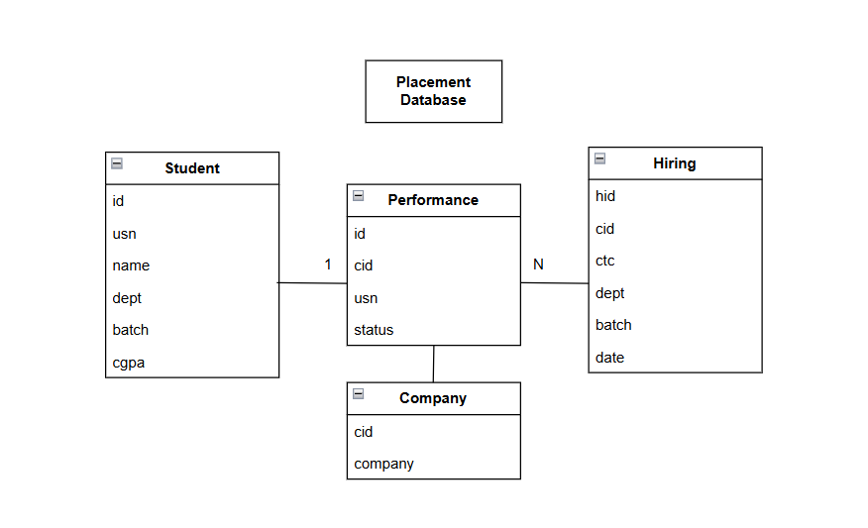

**Actor: User**

* Could be an Admin, Placement Officer, or Student.
* Interacts with dashboard via browser.

**Use Cases:**

* Apply filters (batch, dept, company).
* Analyze placement status.
* Compare salary trends.
* Export hiring records.

**System Components:**

* **Analyzer Module (analyzer.py)**
  + Loads & preprocesses data.
  + Maps status codes.
  + Applies filters.
* **Visualization Module (visualization.py)**
  + Generates charts (bar, pie, stacked graphs).
  + Provides text-based insights.
* **Interface Layer (app.py)**
  + Streamlit front-end.
  + Sidebar filters, KPI cards, graphs, data tables.
* **Database Connector (dbconfig.py)**
  + Connects to MySQL placement_db.

# 7.Code and Implementation :

**1. dbconfig.py**

import mysql.connector

def get_connection():

    conn = mysql.connector.connect(

        host="localhost",

        user="root",

        password="",

        port=3307,

        database="placement_db"

    )

    return conn

**Explanation:**

* **Purpose:** Establishes a connection between the Python application and the MySQL database.
* **Working:**
  + Uses the mysql.connector library to open a connection.
  + Connects to the database placement_db running on localhost:3307 with the username root.
  + Returns a live connection object which can be used in queries.
* **Role in System:** Acts as the *gateway* between the placement data and the analytics system. Without this, the app cannot fetch or update data.

**2. analyzer.py**

This is the **backend processing module** that loads, merges, and filters placement data.

**Placement Status Mapping**

import pandas as pd

from dbconfig import get_connection

PLACEMENT_ORDER = [

    "Not Eligible",

    "Unable to Clear 1st Round",

    "Unable to Clear Technicals",

    "Unable to Clear HR",

    "Shortlisted",

    "Placed",

    "Unable to Clear GD"

]

def map_status(code: int) -> str:

    mapping = {

        0: "Not Eligible",

        1: "Unable to Clear 1st Round",

        3: "Unable to Clear Technicals",

        4: "Unable to Clear HR",

        9: "Shortlisted",

        10: "Placed",

        2: "Unable to Clear GD"

    }

    return mapping.get(code, "Unknown")

* Converts numeric codes from the **performance** table into **readable labels**.
* Ensures all charts and reports use consistent categories (PLACEMENT_ORDER).

**Load Data and Join Tables**

def load_all_data():

    conn = get_connection()

    student_df = pd.read_sql("SELECT * FROM student", conn)

    company_df = pd.read_sql("SELECT * FROM company", conn)

    performance_df = pd.read_sql("SELECT * FROM performance", conn)

    hiring_df = pd.read_sql("SELECT * FROM hiring", conn)

    # Build combined_df with joins

    query = """

        SELECT s.usn, s.name, s.dept, s.batch, s.cgpa,

               p.status, c.company, h.ctc

        FROM student s

        LEFT JOIN performance p ON s.usn = p.usn

        LEFT JOIN hiring h ON p.cid = h.cid

        LEFT JOIN company c ON h.cid = c.cid

    """

    combined_df = pd.read_sql(query, conn)

    conn.close()

    combined_df["Placement_status"] = combined_df["status"].apply(map_status)

    combined_df["Placement_status"] = pd.Categorical(

        combined_df["Placement_status"],

        categories=PLACEMENT_ORDER,

        ordered=True

    )

    return student_df, company_df, performance_df, hiring_df, combined_df

* Connects to MySQL and loads four tables into **Pandas DataFrames**.
* Runs a SQL join to merge student, performance, hiring, and company info.
* Creates a **combined DataFrame** with columns: usn, name, dept, batch, cgpa, status, company, ctc.
* Adds a categorical column Placement_status for ordering results.

**Apply Filters**

def apply_filters(df, batch_filter="All", dept_filter="All", company_filter="All"):

    filtered = df.copy()

    # Batch filter

    if batch_filter == "Last 3 Years":

        all_batches = sorted(filtered["batch"].dropna().unique())

        if len(all_batches) >= 3:

            filtered = filtered[filtered["batch"].isin(all_batches[-3:])]

    elif batch_filter != "All":

        filtered = filtered[filtered["batch"] == batch_filter]

    # Department filter

    if dept_filter != "All":

        filtered = filtered[filtered["dept"] == dept_filter]

    # Company filter

    if company_filter != "All":

        filtered = filtered[filtered["company"] == company_filter]

    return filtered

* Supports filtering by:
  + **Batch** (specific year or last 3 years).
  + **Department** (CSE, ECE, etc.).
  + **Company** (specific recruiter).

Output is a **filtered DataFrame** ready for visualization.

**3. app.py**

This is the **main Streamlit front-end application**.

**Page Configuration & Data Loading**

import streamlit as st

import pandas as pd

from analyzer import load_all_data, apply_filters

import visualization as vz

# --- Page Config ---

st.set_page_config(page_title="Placement Analysis Dashboard", layout="wide")

st.title("📊 Placement Analysis Dashboard")

# --- Load all data once ---

student_df, company_df, performance_df, hiring_df, combined_df = load_all_data()

* Sets dashboard title and layout.
* Loads all required data once at startup.

**Sidebar Filters**

st.sidebar.header("Criteria ")

dept_options = ["All"] + sorted(student_df["dept"].dropna().unique().tolist())

dept_filter = st.sidebar.selectbox("Select Department", dept_options)

batch_list = sorted(student_df["batch"].dropna().unique().tolist())

batch_options = ["All", "Last 3 Years"] + batch_list

batch_filter = st.sidebar.selectbox("Select Batch", batch_options)

company_options = ["All"] + sorted(company_df["company"].dropna().unique().tolist())

company_filter = st.sidebar.selectbox("Select Company", company_options)

# --- Apply filters ---

df = apply_filters(combined_df, batch_filter, dept_filter, company_filter)

Lets users filter placement records dynamically.

**KPI Summary Cards**

st.subheader("📌 Key Placement Metrics")

total_students = df["usn"].nunique()

placed_students = df[df["Placement_status"] == "Placed"]["usn"].nunique()

shortlisted_students = df[df["Placement_status"] == "Shortlisted"]["usn"].nunique()

placement_rate = ((placed_students + shortlisted_students) / total_students * 100) if total_students > 0 else 0

card_style = """

    <div style="background-color:{bg}; padding:20px; border-radius:15px;

                box-shadow:0px 4px 10px rgba(0,0,0,0.25); text-align:center;">

        <h2 style="margin:0; font-size:28px; color:#212121;">{value}</h2>

        <p style="margin:0; font-size:16px; font-weight:bold; color:#424242;">{label}</p>

    </div>

"""

col1, col2, col3, col4 = st.columns(4)

with col1:

    st.markdown(card_style.format(bg="#bbdefb", value=total_students, label="🎓 Total Students"), unsafe_allow_html=True)

with col2:

    st.markdown(card_style.format(bg="#c8e6c9", value=placed_students, label="✅ Placed Students"), unsafe_allow_html=True)

with col3:

    st.markdown(card_style.format(bg="#ffe0b2", value=shortlisted_students, label="📝 Shortlisted"), unsafe_allow_html=True)

with col4:

    st.markdown(card_style.format(bg="#ffcdd2", value=f"{placement_rate:.2f}%", label="📉 Placement Rate"), unsafe_allow_html=True)

st.markdown("---")

* Computes key metrics:
  + Total Students
  + Placed Students
  + Shortlisted Students
  + Placement Rate (%)
* Displays them in styled **info cards**.

**Graphs and Insights**

st.subheader("📊 Placement Analysis Graphs")

if not df.empty:

    color_set = vz.plot_overall_status(df)

    vz.plot_top_recruiters(df)

    vz.plot_batch_wise(df)

    vz.plot_branch_wise(df)

    vz.plot_salary_trends(df)

    vz.plot_conversion_rates(df)

    vz.plot_cgpa_bins(df, color_set)

else:

    st.info("⚠ No data available for selected filters.")

st.markdown("---")

* Calls visualization functions to show insights.
* Provides real-time text interpretations for better understanding.

**Hiring Records Table**

* st.subheader("📑 Hiring Records Table")

if not df.empty:

    pivot_df = df.pivot_table(

        index=["usn", "name", "dept", "batch", "cgpa"],

        columns="company",

        values="Placement_status",

        aggfunc="first"

    ).reset_index()

    st.dataframe(pivot_df, use_container_width=True, height=500)

    st.download_button(

        label="📥 Download CSV",

        data=pivot_df.to_csv(index=False).encode("utf-8"),

        file_name="hiring_records.csv",

        mime="text/csv"

    )

else:

    st.info("⚠ No hiring records available for the selected filters.")

# --- Footer ---

st.markdown("""--------------""")

* Builds a **pivot table**: students vs. companies.
* Provides a **download button** for CSV reports.

1. **visualization.py**

import pandas as pd

import plotly.express as px

import streamlit as st

from analyzer import PLACEMENT_ORDER

# --- Utils ---

def bin_cgpa_value(cgpa):

try:

cgpa = float(cgpa)

except:

return "Unknown"

return "<6" if cgpa < 6 else "6-7" if cgpa < 7 else "7-8" if cgpa < 8 else "8-9" if cgpa < 9 else "9-10"

def make_bar(df, x, y, color, title, text="count", barmode=None, order=None, height=500, angle=0, hover=None):

fig = px.bar(df, x=x, y=y, color=color, text=text, height=height,

title=title, category_orders={color: order} if order else None)

fig.update_traces(texttemplate="%{text}", textposition="inside", hovertemplate=hover)

fig.update_layout(xaxis_title=x.capitalize(), yaxis_title=y.capitalize(),

legend_title=color.replace("_"," ").title(), xaxis_tickangle=angle, barmode=barmode)

st.plotly_chart(fig, use_container_width=True)

# --- Overall Placement ---

def plot_overall_status(df):

df = df[df["Placement_status"] != "Unknown"]

total = df["usn"].nunique()

if total == 0:

return st.info("⚠ No placement data available.")

stats = df.groupby("Placement_status")["usn"].nunique().reset_index(name="count")

stats["percent"] = stats["count"]/total*100

make_bar(stats, "Placement_status","percent","Placement_status",

"Overall Placement Status (%)", text="count", order=PLACEMENT_ORDER)

# --- Text Analysis ---

placed = stats.loc[stats["Placement_status"] == "Placed", "percent"].sum()

shortlisted = stats.loc[stats["Placement_status"] == "Shortlisted", "percent"].sum()

not_placed = 100 - (placed + shortlisted)

st.markdown(f"""

🔎 **Analysis:**

Out of **{total} students**, **{placed:.1f}% were placed** and **{shortlisted:.1f}% shortlisted**.

Around **{not_placed:.1f}% of students could not secure offers**.

""")

# --- Branch/Batch wise ---

def plot_group_wise(df, group_col, title):

df = df[df["Placement_status"] != "Unknown"]

if df.empty:

return st.info(f"⚠ No {group_col}-wise data available.")

totals = df.groupby(group_col)["usn"].nunique().reset_index(name="total")

stats = df.groupby([group_col,"Placement_status"])["usn"].nunique().reset_index(name="count")

stats = stats.merge(totals, on=group_col)

stats["percent"] = stats["count"]/stats["total"]*100

if stats.empty:

return st.info(f"⚠ No {group_col}-wise data available.")

make_bar(stats, group_col,"percent","Placement_status",

f"{title} Placement Status (%)", text="count", order=PLACEMENT_ORDER, barmode="stack", height=600)

# --- Text Analysis ---

best_group = stats.groupby(group_col)["percent"].mean().idxmax()

worst_group = stats.groupby(group_col)["percent"].mean().idxmin()

st.markdown(f"""

🔎 **Analysis:**

**{best_group}** shows the **highest placement performance** among all {group_col}s.

**{worst_group}** has the **lowest placement outcomes**.

""")

def plot_branch_wise(df):

plot_group_wise(df,"dept","Branch-wise")

def plot_batch_wise(df):

plot_group_wise(df,"batch","Batch-wise")

# --- Top Recruiters ---

def plot_top_recruiters(df):

top = df[df["Placement_status"].isin(["Placed","Shortlisted"])]

top = top.groupby("company")["usn"].nunique().reset_index(name="hires").sort_values("hires",ascending=False)

if top.empty:

return st.info("⚠ No recruiter data.")

make_bar(top,"company","hires","company","Top Recruiters (Placed+Shortlisted)", text="hires", height=600, angle=45)

# --- Text Analysis ---

top_company = top.iloc[0]["company"]

top_hires = top.iloc[0]["hires"]

st.markdown(f"""

🔎 **Analysis:**

**{top_company}** emerged as the leading recruiter with **{top_hires} hires**.

""")

# --- CGPA bins ---

def plot_cgpa_bins(df, colors):

df["cgpa_bin"] = df["cgpa"].apply(bin_cgpa_value)

df = df[df["cgpa_bin"]!="Unknown"]

order = ["<6","6-7","7-8","8-9","9-10"]

col1,col2 = st.columns(2)

with col1:

stats_all = df.groupby("cgpa_bin")["usn"].nunique().reset_index(name="count")

make_bar(stats_all,"cgpa_bin","count","cgpa_bin","CGPA Distribution (All)", order=order, height=500)

with col2:

placed = df[df["Placement_status"].isin(["Placed","Shortlisted"])]

if placed.empty:

st.info("⚠ No placed/shortlisted CGPA data.")

else:

stats_p = placed.groupby("cgpa_bin")["usn"].nunique().reset_index(name="count")

make_bar(stats_p,"cgpa_bin","count","cgpa_bin","CGPA Distribution (Placed+Shortlisted)", order=order, height=500)

# --- Text Analysis ---

if not df.empty:

dominant_bin = df["cgpa_bin"].mode()[0]

st.markdown(f"""

🔎 **Analysis:**

Most students who are not placed fall in the **{dominant_bin} CGPA range**.

""")

# --- Salary Trends ---

def plot_salary_trends(df):

stats = df[df["Placement_status"]=="Placed"].groupby("company")["ctc"].agg(highest="max",lowest="min",average="mean").reset_index()

if stats.empty:

return st.info("⚠ No salary data.")

fig = px.pie(stats, names="company", values="average", title="Average Salary Distribution", color_discrete_sequence=px.colors.qualitative.Set3)

fig.update_traces(textinfo="percent+label")

st.plotly_chart(fig, use_container_width=True)

# --- Text Analysis ---

top_salary = stats["average"].max()

top_company = stats.loc[stats["average"].idxmax(), "company"]

st.markdown(f"""

🔎 **Analysis:**

**{top_company}** offers the **highest average salary** of approximately **{top_salary:.2f} LPA**.

""")

# --- Conversion Rates ---

def plot_conversion_rates(df):

if df.empty:

return st.info("⚠ No conversion rate data.")

conv = df.groupby("company").apply(lambda x: x[x["Placement_status"]=="Placed"]["usn"].nunique()/x["usn"].nunique()*100 if x["usn"].nunique()>0 else 0).reset_index().rename(columns={0:"conversion"})

if conv.empty:

return st.info("⚠ No conversion rate data.")

conv["conversion"] = conv["conversion"].round().astype(int)

make_bar(conv.sort_values("conversion",ascending=False),"company","conversion","company","Interview-to-Offer Conversion (%)", text="conversion", height=600, angle=45)

# --- Text Analysis ---

best_company = conv.loc[conv["conversion"].idxmax(), "company"]

best_rate = conv["conversion"].max()

st.markdown(f"""

🔎 **Analysis:**

**{best_company}** shows the **highest interview-to-offer conversion rate** at **{best_rate}%**.

""")

This module handles **all data visualizations**.

**Key Functions**

1. **plot_overall_status(df)**
   * Shows placement status distribution (Placed, Shortlisted, Not Eligible, etc.).
   * Provides percentage + count.
   * Adds text-based analysis.
2. **plot_group_wise(df, group_col, title)**
   * Used by plot_batch_wise() and plot_branch_wise().
   * Compares placement results across years or departments.
   * Highlights best and worst performing groups.
3. **plot_top_recruiters(df)**
   * Lists top companies by number of hires.
   * Identifies the leading recruiter.
4. **plot_salary_trends(df)**
   * Creates pie chart of average salaries offered by companies.
   * Highlights the company with the best package.
5. **plot_conversion_rates(df)**
   * Calculates interview-to-offer conversion percentage for each recruiter.
   * Shows which company is most efficient.
6. **plot_cgpa_bins(df)**
   * Groups students into bins (<6, 6–7, 7–8, 8–9, 9–10).
   * Compares placement success across CGPA ranges.
   * Gives insights like “most placed students have CGPA between 8–9”.

# 8. Output Screenshots & Explanation:

**Dashboard KPIs** – Displays key placement metrics like total students, placed students, shortlisted students, and placement rate.

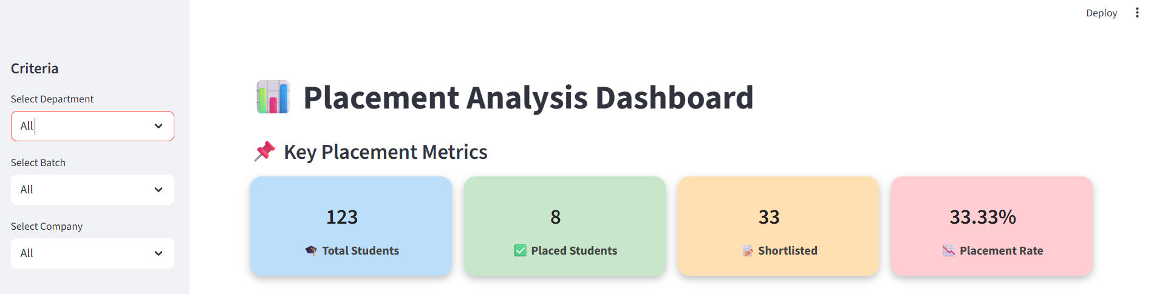

FILTERS :

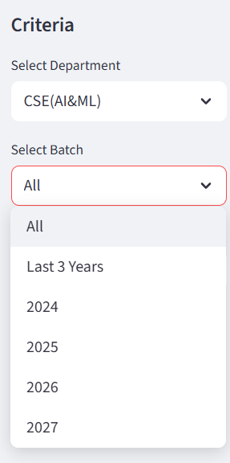 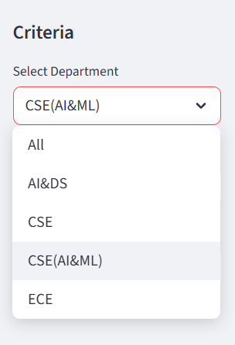 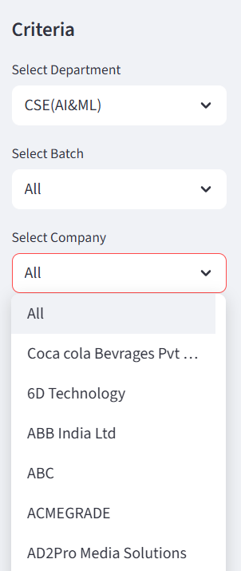

**Filter by Department** – Allows selection of a specific department (CSE, AI&DS, AI&ML, ECE, etc.) for analysis.

**Filter by Batch** – Enables analysis for specific batches (e.g., 2024, 2025, 2026) or across the last three years.

**Filter by Company** - Enables analysis for specific companies.

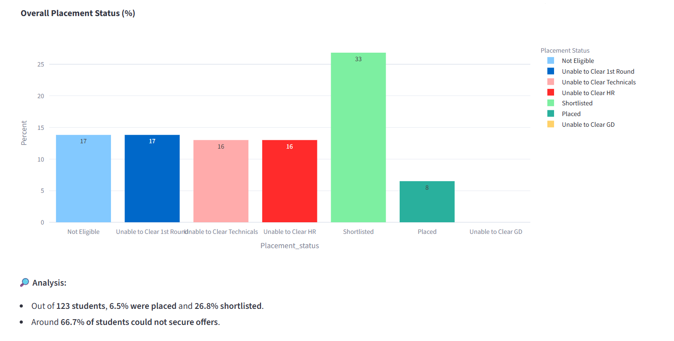

**Overall Placement Status (Bar Graph)** – Shows distribution of students across different placement statuses (e.g., Placed, Shortlisted, Not Eligible).

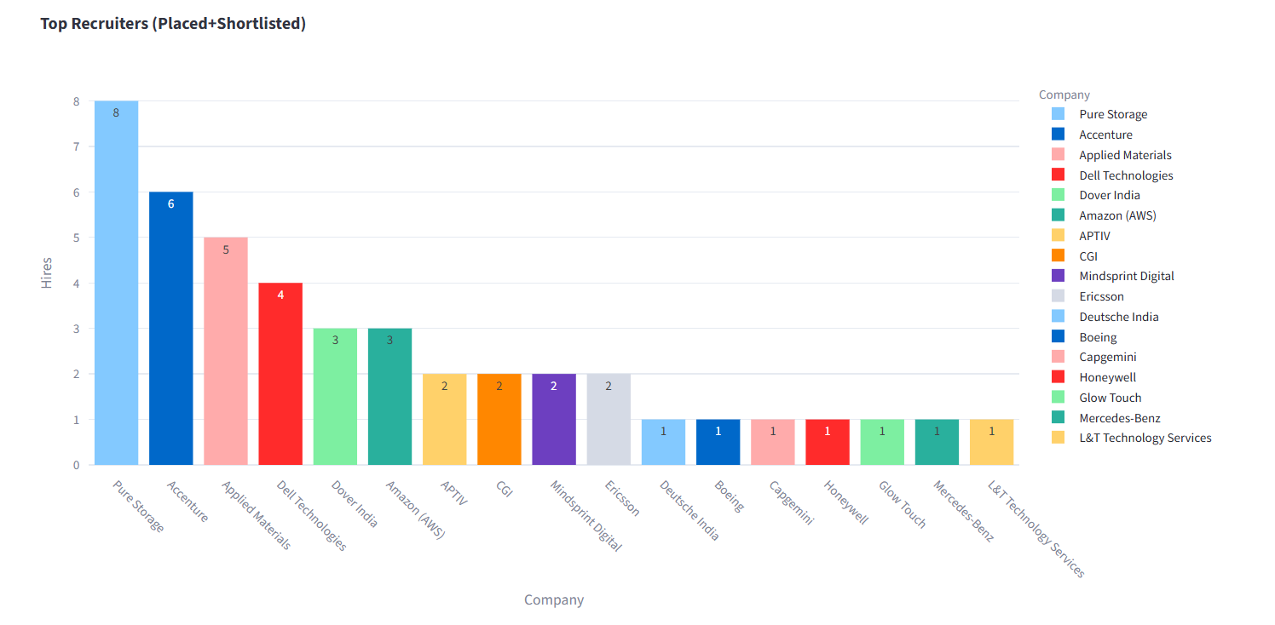

**Top Recruiters Chart** – Ranks companies based on the total number of hires (Placed + Shortlisted).

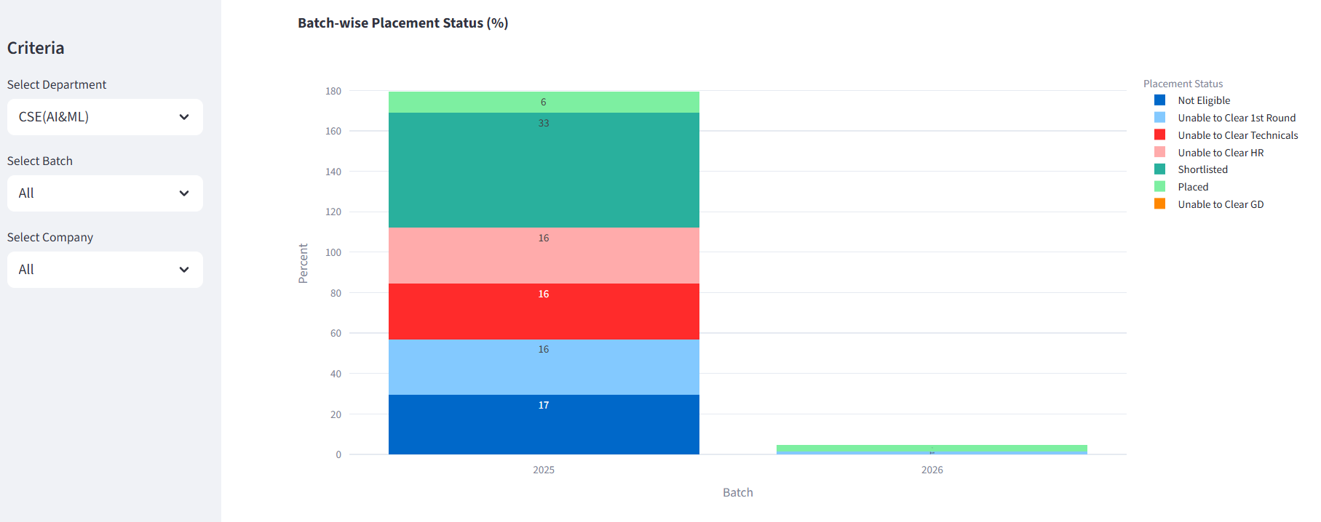

**Batch wise Analysis**

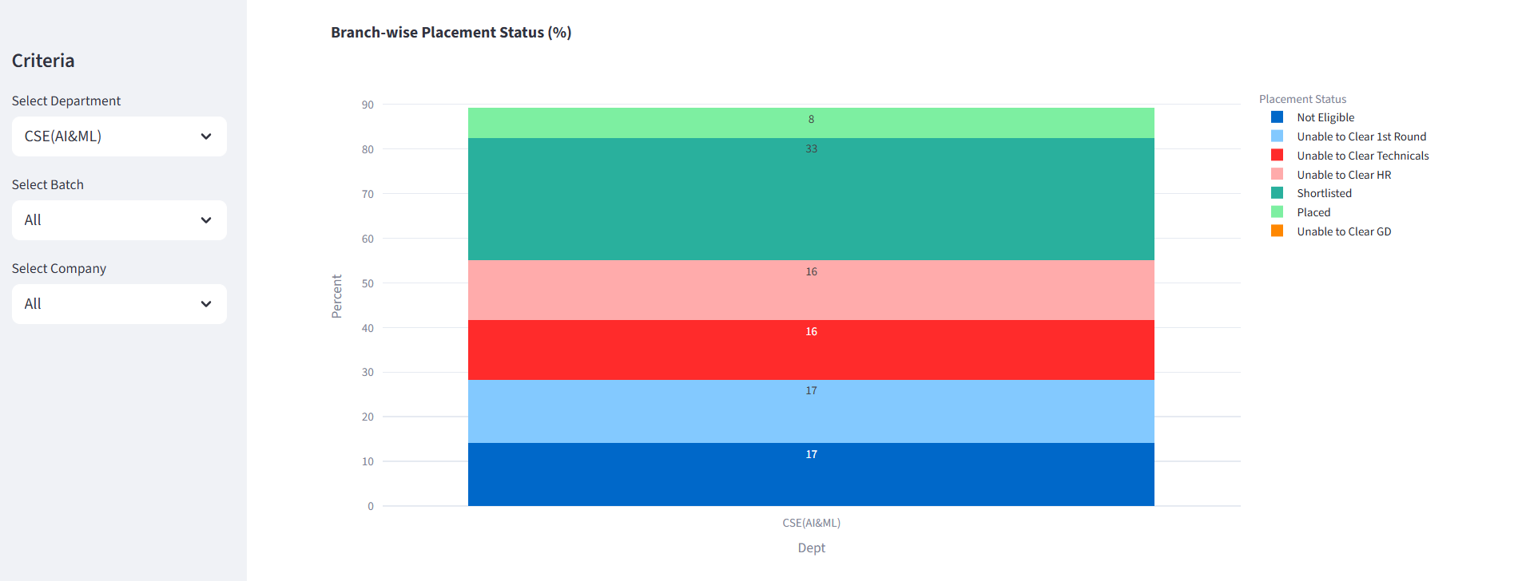

**Branch wise Analysis**

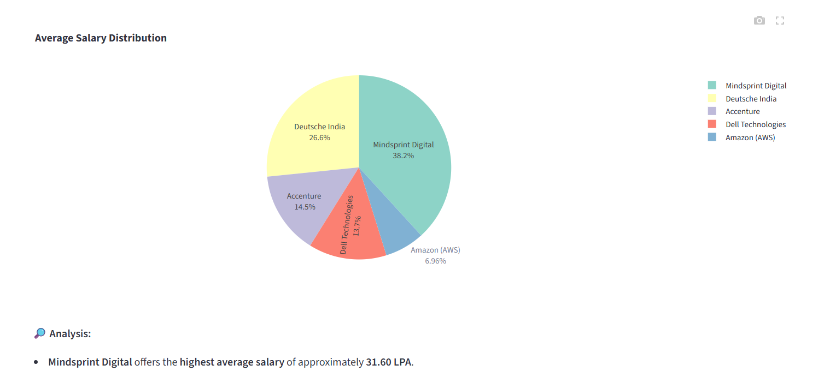

**Salary Distribution (Pie Chart)** – Visualizes average salary packages offered by different companies.

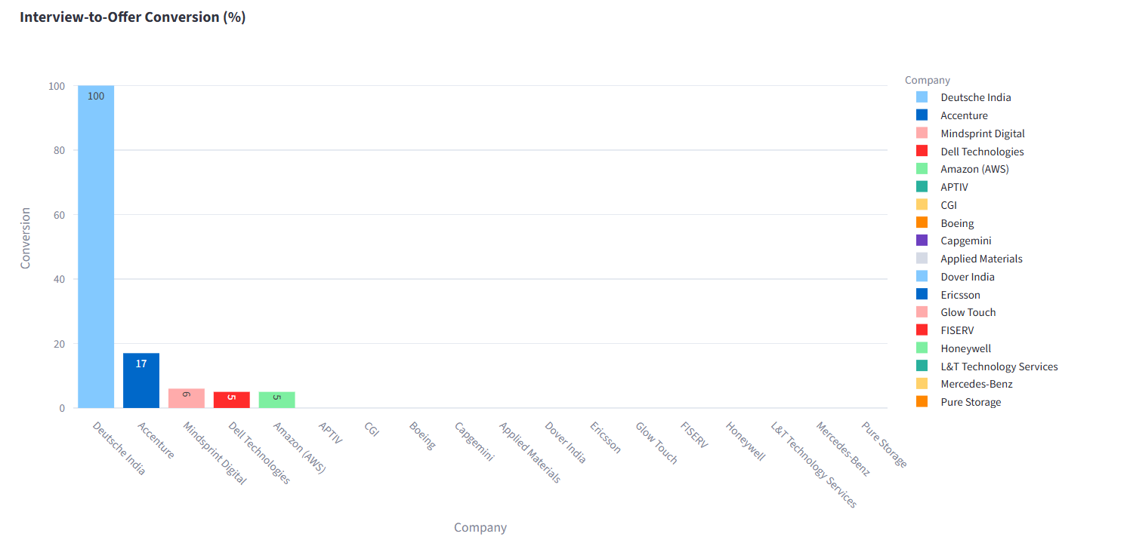

**Interview-to-Offer Conversion** – Displays recruiter efficiency in converting interviews into final offers.

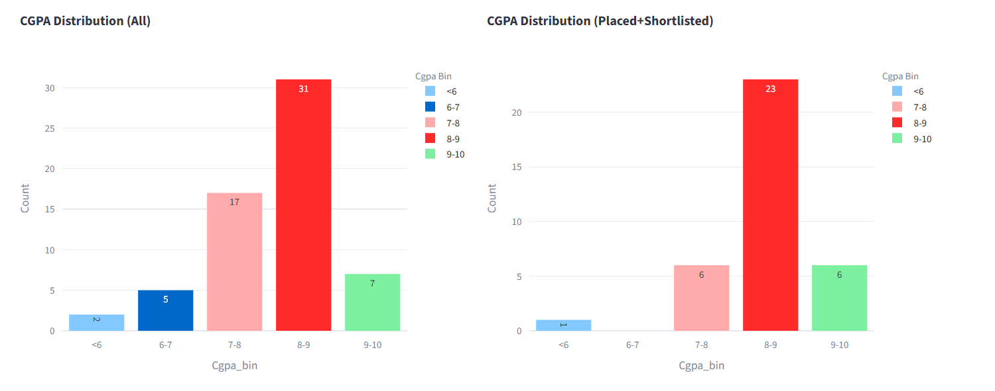

**CGPA Distribution (All vs Placed/Shortlisted)** – Compares overall CGPA ranges with those of successfully placed/shortlisted students.

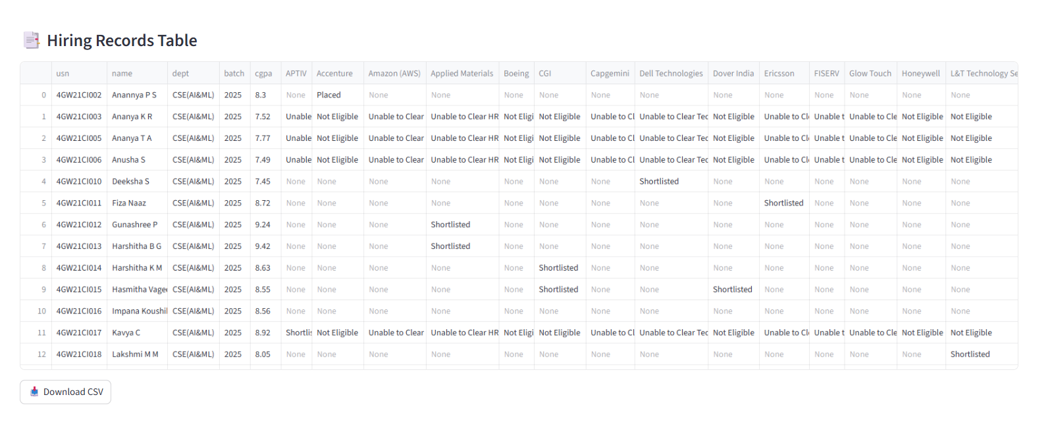

**Hiring Records Table** – Provides detailed student-wise hiring records with placement outcomes and downloadable CSV option.

# 9. Conclusion :

The **Placement Analysis Dashboard** provides a centralized, interactive, and visual tool for analyzing placement outcomes.

**Key outcomes include:**

* Identified recruiters with the **highest hiring counts and best conversion rates**.
* Highlighted **departments and batches** with the strongest placement performance.
* Demonstrated the correlation between **CGPA and placement success**, helping students understand the impact of academics on recruitment outcomes.
* Enabled administrators to **download hiring records** for official documentation and reporting purposes.

This solution effectively bridges the gap between **raw placement data** and **actionable insights**, making the placement process more **transparent, efficient, and data-driven**.

# 10. Closure :

The Placement Analysis Dashboard is a **scalable and extendable system** that empowers placement officers, faculty, and students with meaningful insights.

**Current Achievements:**

* Real-time **filtering** by batch, department, and company.
* Interactive **graphs and dashboards** for easy interpretation.
* Exportable hiring records for institutional use.

**Future Enhancements may include:**

* **Predictive modeling** to estimate student placement probability.
* Automated **PDF report generation** for each department or batch.
* Integration with **resume parsing** tools and **Applicant Tracking Systems (ATS)** to further streamline placement management.

This ensures the system will continue to grow into a comprehensive **decision-support platform** for placement analytics.

# 11. Bibliography :

* **Streamlit Documentation**: [https://docs.streamlit.io/](https://docs.streamlit.io/?utm_source=chatgpt.com)
* **Pandas Documentation**: [https://pandas.pydata.org/](https://pandas.pydata.org/?utm_source=chatgpt.com)
* **Plotly Express**: [https://plotly.com/python/plotly-express/](https://plotly.com/python/plotly-express/?utm_source=chatgpt.com)
* **MySQL Documentation**: [https://dev.mysql.com/doc/](https://dev.mysql.com/doc/?utm_source=chatgpt.com)
* **Python Documentation**: [https://docs.python.org/](https://docs.python.org/?utm_source=chatgpt.com)